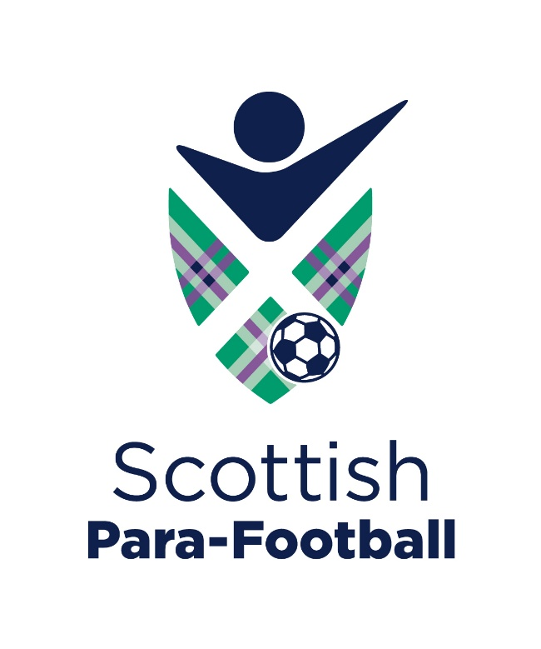


Scottish Para-Football
Privacy Notice

August 2026

Scottish Para-Football Privacy Notice
Last updated: August 2026
Who we are
Scottish Para-Football is the national governing body for disability football in Scotland.
Scottish Para-Football is a registered Scottish charity (SC048491).
If you have any questions about this Privacy Notice or how we use your information, please contact:
Scottish Para-Football
Hampden Park
Glasgow
G42 9AY
Email: ashley.reid@scottishparafootball.org.uk

What information we collect
Depending on the activity, we may collect:
- Parent/carer name
- Child's name
- Date of birth
- Email address
- Telephone number
- Postcode
- Football experience
- Information about a player's disability or eligibility (for example cerebral palsy, acquired brain injury or childhood stroke)
- Emergency contact details (where appropriate)
We only collect information that is necessary for the activity you are registering for.

Why we collect your information
We use your information to:
- Register players for events and activities
- Contact you about your booking
- Assess demand for disability football opportunities across Scotland
- Develop new football sessions and programmes
- Support player pathway opportunities
- Meet our safeguarding responsibilities
- Maintain appropriate records
Where you have agreed, we may also contact you about future Scottish Para-Football activities.

Lawful basis
We process your information because:
- it is necessary to organise and deliver our football activities;
- it is in Scottish Para-Football's legitimate interests to develop disability football opportunities across Scotland; and
- where required, we will ask for your consent before sending future communications.
Where we collect information about a player's disability, we do so only where it is necessary to provide appropriate football opportunities and support.

Who we share information with
We will only share personal information where necessary.
This may include:
- Scottish Football Association
- Scottish Para-Football member organisations
- Coaches and volunteers involved in delivering activities
- Venue providers (where required)
- Emergency services (where necessary)
Information is only shared in accordance with data protection legislation and Scottish Para-Football's Data Sharing Agreement.

How long we keep information
We only keep personal information for as long as necessary to fulfil the purpose for which it was collected or where required by law or safeguarding guidance.

Keeping your information secure
Scottish Para-Football takes appropriate technical and organisational measures to protect personal information from loss, misuse or unauthorised access.

Your rights
Under UK data protection law you have the right to:
- access your personal information
- ask us to correct inaccurate information
- request that information is deleted (where appropriate)
- restrict or object to processing in certain circumstances
- withdraw consent where processing is based on consent
- complain to the Information Commissioner's Office (ICO)

Contact us
If you have any questions about this Privacy Notice or how we use your information, please contact:
Ashley Reid
Chief Executive Officer
Scottish Para-Football
Email: ashley.reid@scottishparafootball.org.uk

